NEWSLETTER
Newsletter nr.16 – December 8 2018

“Intensifying and manifesting your personal relationship with the Light”

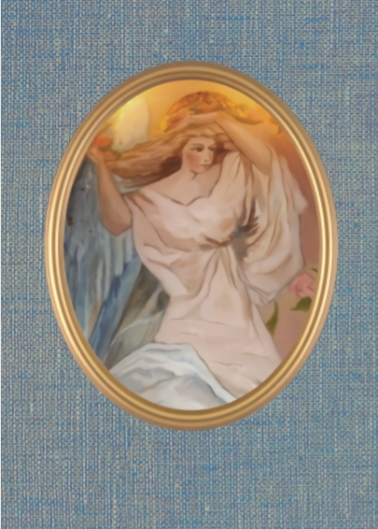

“The way to new consciousness is also called the way of awakening; which is seeing
through the night.
Whoever wakes up from the night is in the Light. In him is the Light”.
The voice of the roseheart.

Workshop

“Intensifying and manifesting your personal relationship with the Light”

Wednesday morning 30- 1-2019 from 9.30 till 12.00

During the workshop various possibilities are offered to intensify our connection with “the Light”. During the winter period of the year, we can use our efforts to deepen the connection with ourselves and the World around us. During the workshop we will reinforce and empower our intentions in a spiritual way. Various possibilities are offered, which you can use to get started.

The different perspectives will be:

- Alignment with the Angels of Light.
- How you can create a special Light place in your living environment?
- Awareness and transformation.
- Working with the candle, such as receiving messages via the element Fire.
- Making an Angel light circle.

Guiding meditation / visualization will be used. This creates balance and a better future, which is not only serving yourself but also others.

Request by mail: aedskevansteenbergen@hotmail.com

Consultations
- Private consultations to support you with your questions and spiritual development.
If desired, there is the possibility for a more intensive supervision.
- Healing, working on blockages.

&

Courses

- Intuitive painting on Wednesday 1x a month.

- Training Angel Healing
Deepening your contact and working with Angels is the focus.

&

Workshop

“Intensifying and manifesting your personal relationship with the Light”

Wednesday 30- 1-2019 from 9.30 till 12.00
The costs are € 20 (a workbook, coffee/tea are included).

Request by mail: aedskevansteenbergen@hotmail.com

Highly recommended

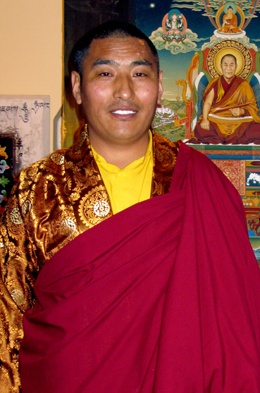

TULKU SONAM CHOEDUP RINPOCHE / SHAGRASCHOOL

COMPASSION

We are glad to welcome Tulku Sonam Choedup Rinpoche again the coming year in the Netherlands.
The visit will take place from 28-2-2019 till 12-03-2019
If you would like to organize a meeting such as a teaching, puja or meditation for the benefit of Tulku Sonam’s life mission, you can contact me. It is a very nice opportunity to make contact with the oldest Tibetan tradition.
Especially now in our contemporary society this philosophy contains a source of valuable information and give answers to many important questions in our life.
Deeper insights are given on themes such as, for example:
“Living from Compassion, Meditation, Pujas, Burn Out, Forgiveness”.

- The proceeds of the meeting are all for the benefit of his life mission.
- For more information: TULKU SONAM CHOEDUP RINPOCHE / SHAGRASCHOOL

Highly recommended

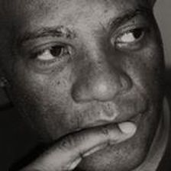

JANSENIUS T. LANGE JR. / SELF DEVELOPMENT WISDOM INSTITUTE

“Any Mind can reinvent itself successfully. Why…? Because that is also one of its energy ability nature. The desire to do so effectively, relies on the personal responsibility of a person to choose the way of the renewal of the mind universal wisdom and education…”

“The Renewal of the Mind Education”
“Renewal of the Mind is an educational solution designed specifically to guide and guard the mind, throughout its journey of reinventing its own self…”
Physically surviving a bad experience, does not means that the mind is done with the nightmare. What this really mean is this; now is the urgent time for the person who went through the experiences, to begin the process of freeing his or her mind from harmful knowledge. WHY…? So it does not continue repeating the symptom over and over again, by error… Unfortunately, this has been the case for too many individuals, because they are not yet educated to the only wisdom that is known to do just that for them – And until then, they will continue being hurt, at each time their Minds revisit the misfortune…

“When the mind continues to reviewing hurtful moments, it is also bullying itself as well – and this has been the cause for almost all addictions, the process that gets started”.
Hurt produces Pain. The person who is experiencing pain, is vulnerable to do and consume anything that can ease the suffering. Prescribed Pain Killers, Alcohol, Sex, Food or street drugs. To add this is: the mind which is being bullied, will bully other fellow human beings, as well, period. – Not because a person is mean spirited, but because they are in great pain. Did you know that, most individuals whose minds are bullying them, are not even aware of that fact…?
I create, cultivate and teach “The Renewal of the Mind Universal Wisdom and Education” to bring about that solutions to most human sufferance’s. Minds do not aged, because of its Energy Status. The conditions of the mind does and can happen to humans of all ages. Because these are universal wisdom and education, teenagers should attend the classes as well…

WWW.WISEMINDDEVOLEPMENT: Jansenius T. Lange Jr.
TIP
SPECIAL SERVICE ON DECEMBER 24,25 AND 31 2018
On December 25,26 and 31 – 2018 you are very welcome to call me in the morning between 9.00 and 11.00 for a short free consultation by phone call.

Tel.: (+31)06-33819247

For more information: Spiritual Therapy: www.aedskevansteenbergen.nl
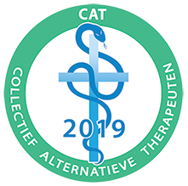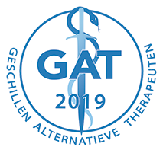

As accredited Alternative Therapist associated with CAT Collective Alternative Therapists

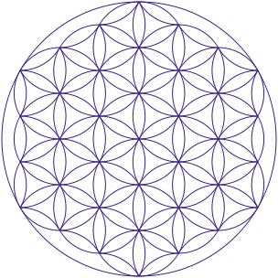

“Be The Change You wish To See In The World”, Ghandi
Light and Love, AEdske van Steenbergen

