Newsletter 8

NEWSLETTER
Newsletter nr.8 – 29 - 4/2016

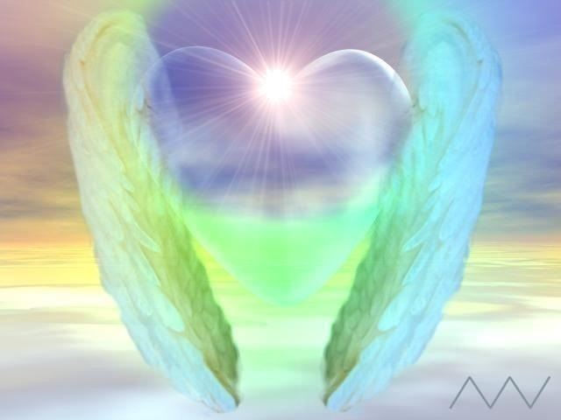
“This is love: to fly toward a secret sky, to cause a hundred veils to fall each moment. First, to let go of life. In the end, to take a step without feet; to regard this world as invisible, and to disregard what appears to be the self. Heart, I said, what a gift it has been to enter this circle of lovers, to see beyond seeing itself, to reach and feel within the breast“. Rumi

Archangel Rafael
healing and truth

Workshop May 25 2016

From 9.30-12.00 o’clock

Archangels are “bridge - angels”. They are a bridge between the Divine and the earthly material and protect many levels of creation. They are often associated with the seven rays of colored flames and each has its own specific task.
Archangel Rafael is the fifth Archangel, who serves the green ray. This is the radius of healing and truth.
Rafael means "God heals" and you always can ask him when healing is needed. During this workshop we will work together with the energy of Archangel Rafael as a guardian to accompany you in healing.
Archangel Rafael can work well together in the group of Healing Angels, such as Archangel Michael while breaking cords and healing this.
The energy of Archangel Rafael is soft, enveloping, healing, brightening, cleaning, delicate and yet powerful.
He can help with every healing and renewal on Earth and in the cosmos. His main task is helping people. He heals all areas of us: physical, emotional, thoughts, situations and our relationship to the Divine Light. Rafael helps through feeling lost and loneliness, as we are not satisfied with ourselves, with weakness and exhaustion.
He helps guiding world leaders, assisting countries and their people and those in need.
Currently his healing is more than ever needed, to live from unity and solidarity with each other on a deeper and more loving way. How can we succeed to see and treat our fellow men as a part of ourselves? This is at the moment our great challenge.
Archangel Raphael brings awareness and let people experience their individual responsibility. Archangel Rafael brings healing at all levels, strengthening, renewal and transformation of the past.

Guiding meditation / visualization will be used.
By asking yourself regularly for the guidance of Archangel Michael, there will be positive changes on all levels of your existence. This creates balance and a better future, which is not only serving yourself but also others.

The workshop will be given at home on Wednesday May 25 from 9:30 - 12:00 o’clock.
Address: Reijgershof 51
Ouderkerk a / d Amstel
The costs are € 20 (coffee and tea are included).
Request by mail:
http://www.aedskevansteenbergen.nl/en/contactform/

Courses
- Intuitive painting on Wednesday 1x a month.
- Training Angel Healing
Deepening your contact and working with Angels is the focus.

Consultations
- Private consultations to support you with your questions and spiritual development.
If desired, there is the possibility for more intensive counseling.
- Healing

AGENDA
Wednesday morning May 25 2016
Workshop Archangel Rafael﻿
On request by mail:
http://www.aedskevansteenbergen.nl/contact/

--------------------------------------------------------------------------------------------------------------------

HIGHLY RECOMMENDED

CHIEF HENRY RED CLOUD EUROPEAN TOUR 2016

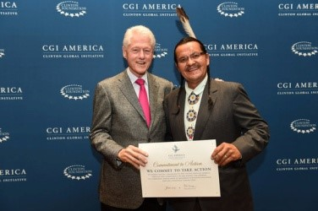

SJAMANISM IN THE NETHERLANDS
NATIVE MEDICINE ACADEMY "rebuild the old way"
CHIEF HENRY RED CLOUD VISITS THE NETHERLANDS
SATURDAY JUNE 4 2016
For statement and information
Tickets to buy only in advance via:

ORDERING TICKETS

For more information please mail to:
agenda@spiritueelcentrumnederland.nl

Admission: € 25
*The official language is English and the proceeds will go to the reservation of the Lakota "Pine Ridge".

HIGHLY RECOMMENDED

Tulku Sonam Choedup Rinpoche

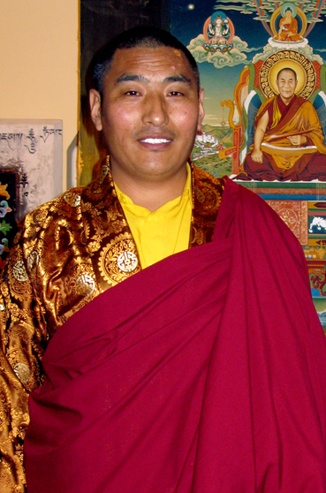

In November 2016 Tulku Sonam Choedup Rinpoche will visit again the Netherlands. If you like to organize a meeting such as a teaching, puja or meditation, you can approach me for this and sign in already. It is a very nice way to make contact with the oldest Tibetan tradition.
*The official language is English and the revenues will go to the foundation from Tulku Sonam Choedup Rinpoche.

Request by mail: http://www.aedskevansteenbergen.nl/contact/
For more information:
http://www.tulkusonam.nl/en/tulku_sonam / http://www.shagraschool.org/

HIGHLY RECOMMENDED

Pastor Frank Chisale – country director of Malawi

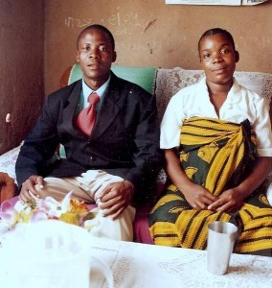

URGENT!

Pastor Frank and his wife Asa face a nearly impossible task, because the conditions in Malawi are exceptionally difficult. Many deaths from HIV infection.
* There is an urgent need for food aid for the children.
* Pastor Frank would also like to get in touch with people who can advise him on climate Change.
* Do you have a good idea or you like to help Pastor Frank and the community, than you are very welcome to contact him.

PASTOR FRANK – MALAWI / PASTOR FRANK AND HIS WIFE ASA – MALAWI

HIGHLY RECOMMENDED

Jansenius T. Lange.Jr.

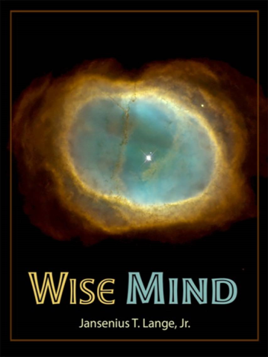
“Spiritual light is life and Spiritual life is hope…” -JTL
SELF DEVELOPMENT WISDOM INSTITUTES
NEW
Wise Mind
Available in all e-book formats and through all e-book retailer worldwide, (Except on Amazon.com)
“ I am very pleased to tell you that the first Wise Mind Wisdom Education book volume, (in a series of seven) is officially launched and available on our website’.
With gratitude, Tito
www.wiseminddevelopment.Org

For more information: Spiritual Therapy: www.aedskevansteenbergen.nl
“Be The Change You wish To See In The World”, Ghandi
Light and Love, AEdske van Steenbergen

