Newsletter

nr. 22, March 9th 2021

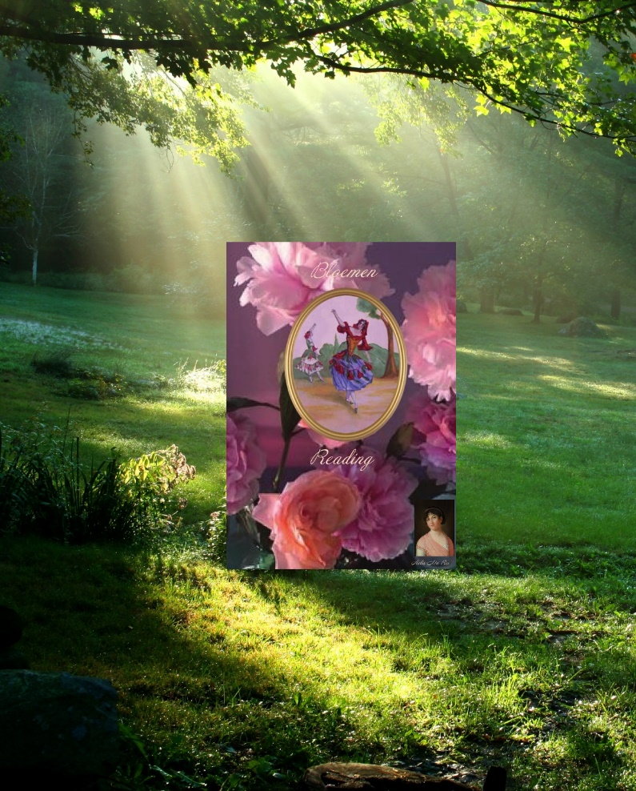
"It is the Light that opens
the heart of the flower to the world"
"It is the Light that opens the heart of the flower to the world"
22. Newsletter- March 8the 2021
We also can experience, just like a flower, that the Light opens our hearts. Our need is undeniable grept and we are always searching for this, consciously or unconsciously. Sometimes it is not possible to experience, because of the obstacles we meet on our path. We can feel disconnected and it seems like everything is stagnating, but the Divine Light remains always present and seeks connection. The power of this is enormous and each of us carries a spiritual power within. Opening yourself to this, allows you to experience an unprecedented energy of joy in yourself. Allow yourself the possibility to experience a healing within yourself.
Flowers have a great influence and also a healing effect on the psyché and are often given to express feelings such as joy, affection, gratitude, compassion in grief, to support difficulties, etc.
* Image ~ painting:
The Pomegranate from the Flower Oracle of Mlle Lenormand.
The dancers incite passion, but maintain their self-control. They forget time and space. The pomegranate represents an artistic personality, new relationships, fertility and entering a relaxed and pleasant period in life.

Archangels are “bridge – angels”. They are a bridge between the Divine and the earthly material and protect many levels of creation. They are often associated with the seven rays of colored flames and each has its own specific task. Like a bridge, they make a connection in two directions. They are not only serve man, but all of creation with: – Transform the divine impulses. – Experiencing the Divine making possible – To guide people on their way to unity.

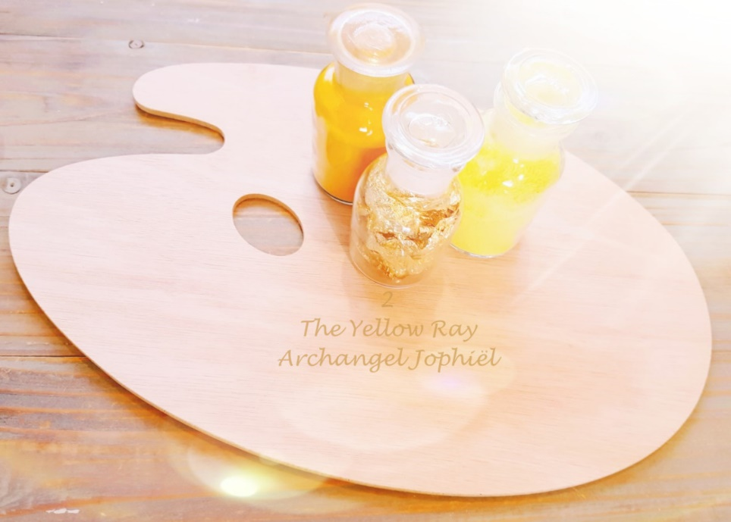

ARCHANGEL JOPHIEL
Archangel Jophiël is the second Archangel, who serves the Yellow Ray.
This is the Ray of Wisdom, Enlightenment and Creativity.
Archangel Jophiel is the guardian angel of artists. From harmony and in keeping with your rhythm of life, creative inspirations are shaped within yourself as seeds of the Light.
Archangel Jophiel ~ "Beauty of God"
Archangel Jophiel stands for "Beauty of God". His healing energy brings you closer to your inner Self, Joy and Happiness. By letting shine the Light within yourself, the seeds of Light in your heart can sprout so that your life becomes lighter.
Flowers, with their beautiful appearances, are messengers of the Divine Light.
A Reading ~ Healing is an intense experience, while focussing on the person and the theme of the question. The information that is reveiled is important at that moment.
A Flower Reading with Archangel Jophiel is about positivity, manifesting beauty in art, wisdom, improving the atmosphere in the environment, joy and happiness.
During a Flower Reading, the energy around the flower is read from the connection with Archangel Jophiel. The personal message that the flower carries within it will be brought forward during the Reading. A “Flower Reading with Archangel Jophiel” will be attuned to; The Healing Energy of Archangel Jophiel and the Flower.
READINGS

Cosultations

For more information: www.aedskevansteenbergen.nl

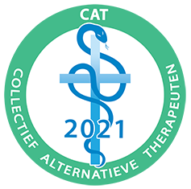
As accredited Alternative Therapist associated with CAT Collective Alternative Therapists

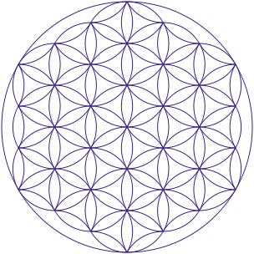

Aelis Ma Rei

Love and Light, Ædske van Steenbergen

