# **Newsletter**

# **Newsletter nr. 21, January 12th 2021**

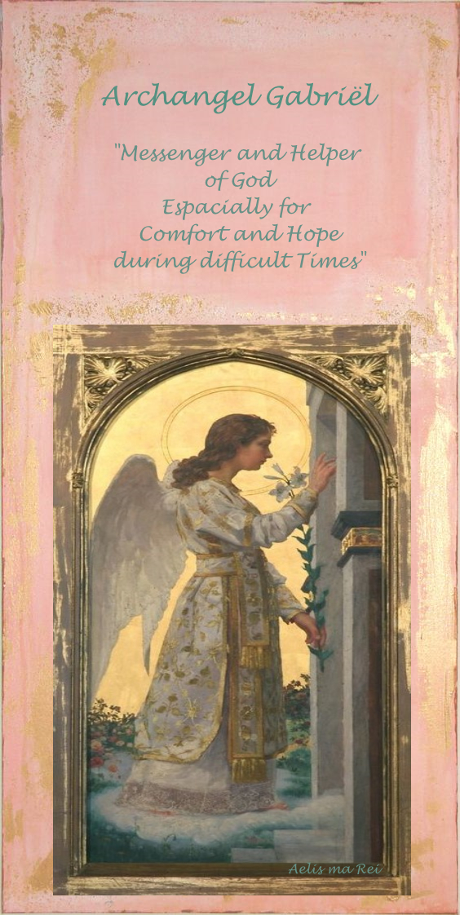

Divine guidance for connection in difficult times

by Archangel Gabriël

~ God is my Strength ~

One of the special tasks of Archangel Gabriel is to serve humanity as a powerful messenger and helper of God.

Especially as a transition Angel in difficult times he can help you, when you listen and allow him, to stay in touch or to reconnect with the Divine world of Light and Love.

In this way it is possible to focus on Unity and to experience Inner Peace despite the duality and division of our present existence.

Feelings of hopelessness for example, can be transformed into relief.

You can ask for Strength to focus on what is important to you, while accepting and letting go of illusions  in this upcoming time period.

When you look deep inside you can pay attention to feelings of for example vulnerability, because they also can lead to a beautiful journey of the heart.

Archangel Gabriel can profide clarity and give comfort in situations of trauma or confusion. His energy is powerful, uplifting, brings inner peace while helping you to connect with the healing energy of the Divine Source.

At this moment only a Cosultation by Phone is possible

You can make an appointment by email: aedskevansteenbergen@hotmail.com

For more information: [www.aedskevansteenbergen.nl](http://www.aedskevansteenbergen.nl)

 

As accredited Alternative Therapist associated with CAT Collective Alternative Therapists



Aelis Ma Rei

Love and Light, Ædske van Steenbergen